TP 5 : Docker Engine, Jenkins, CI/CD
Meggouri Ismail
-------------------------------------------------------------------------------------------------------
Partie 1: CI
- Jenkins installation:
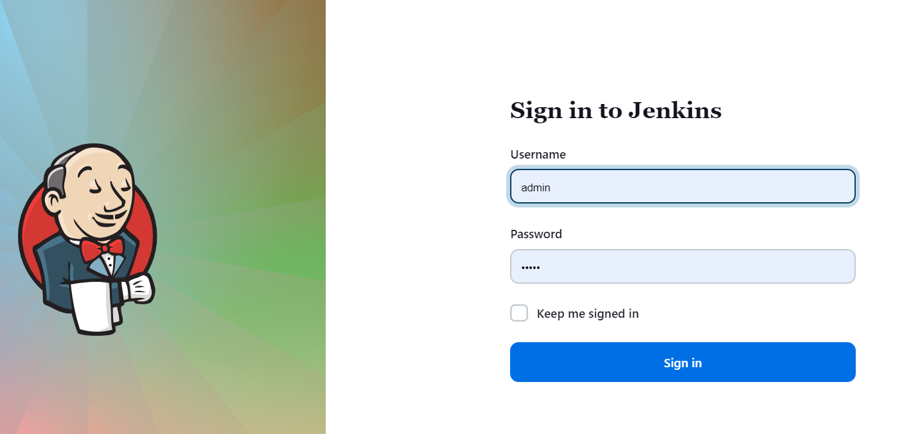
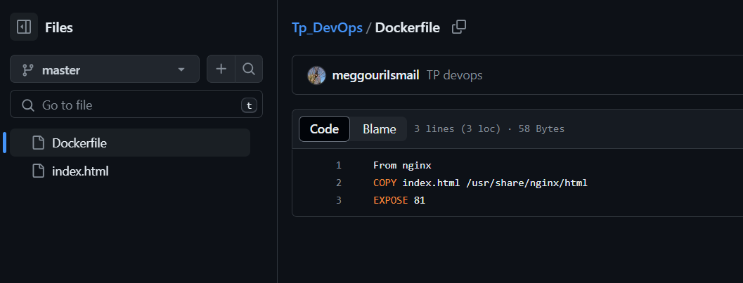
- TP4 project structure, DockerFile & repo:
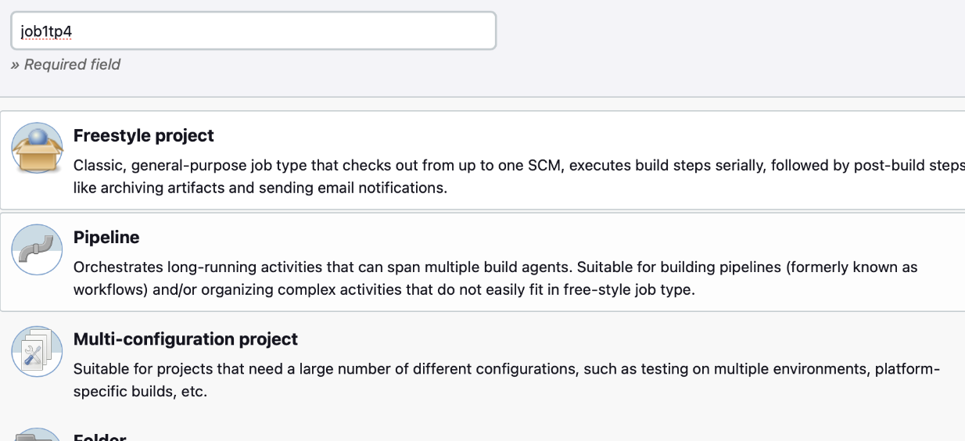
- creation of the job job1tp4

- add Docker Plugins
- Job1Tp4 Config
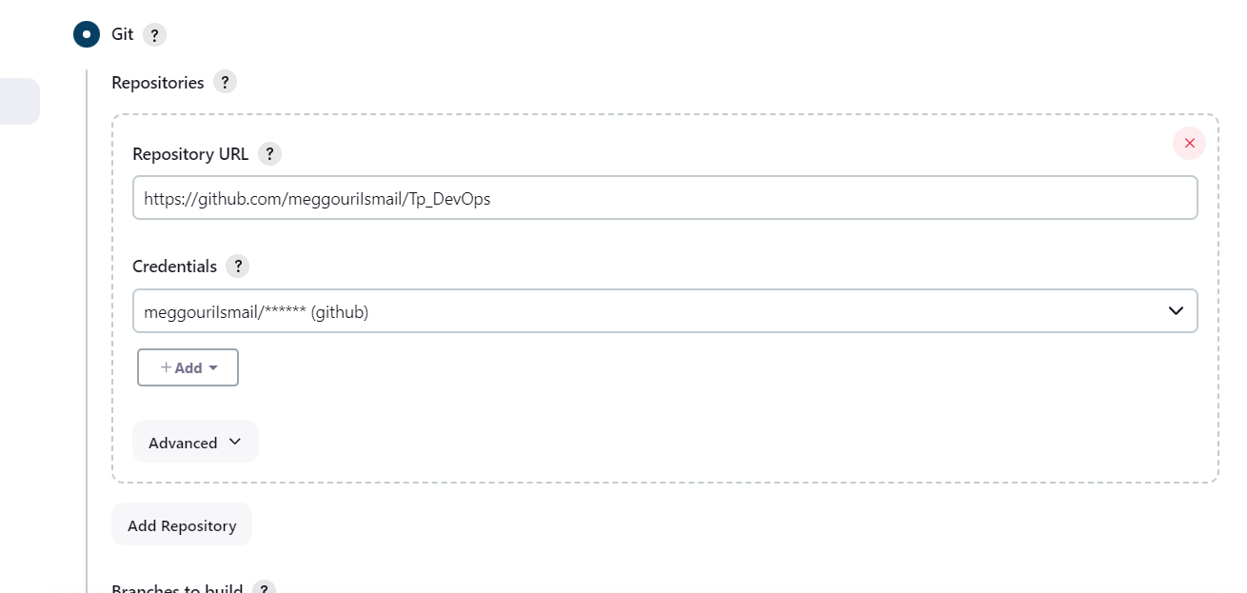
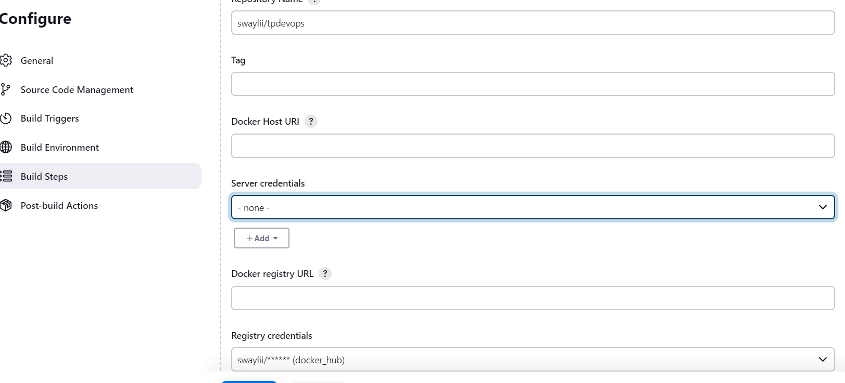

- rebuild job after a change in git:
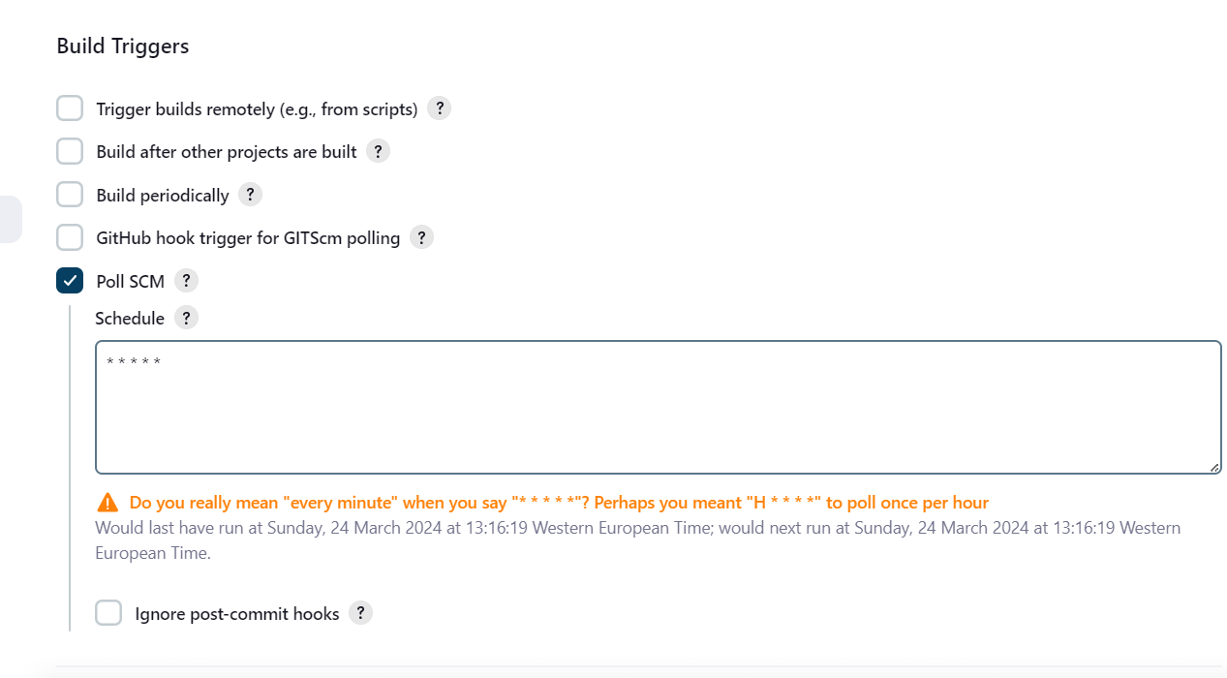

- Build and push:

Partie 2: CI/CD (continuous integration/continuous deployment)

Freestyle job ‘job2tp4’ with a shell script to deploy the image:
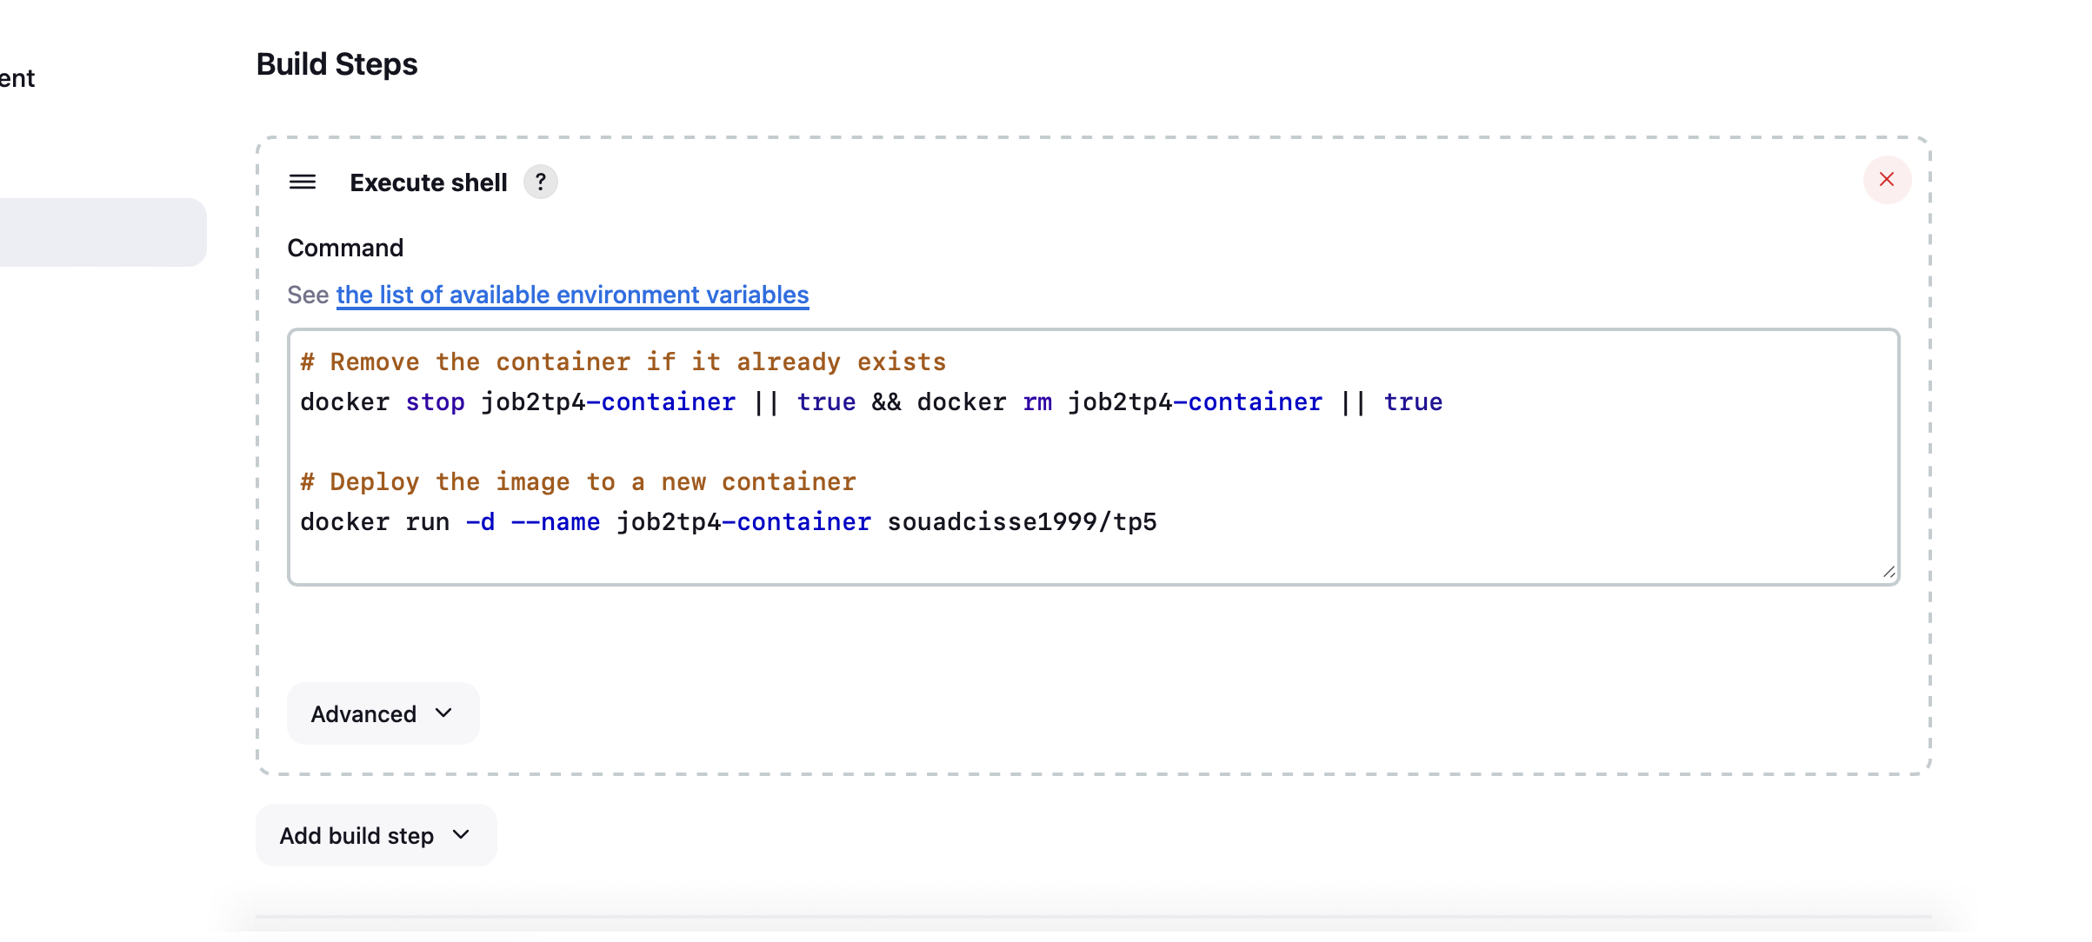
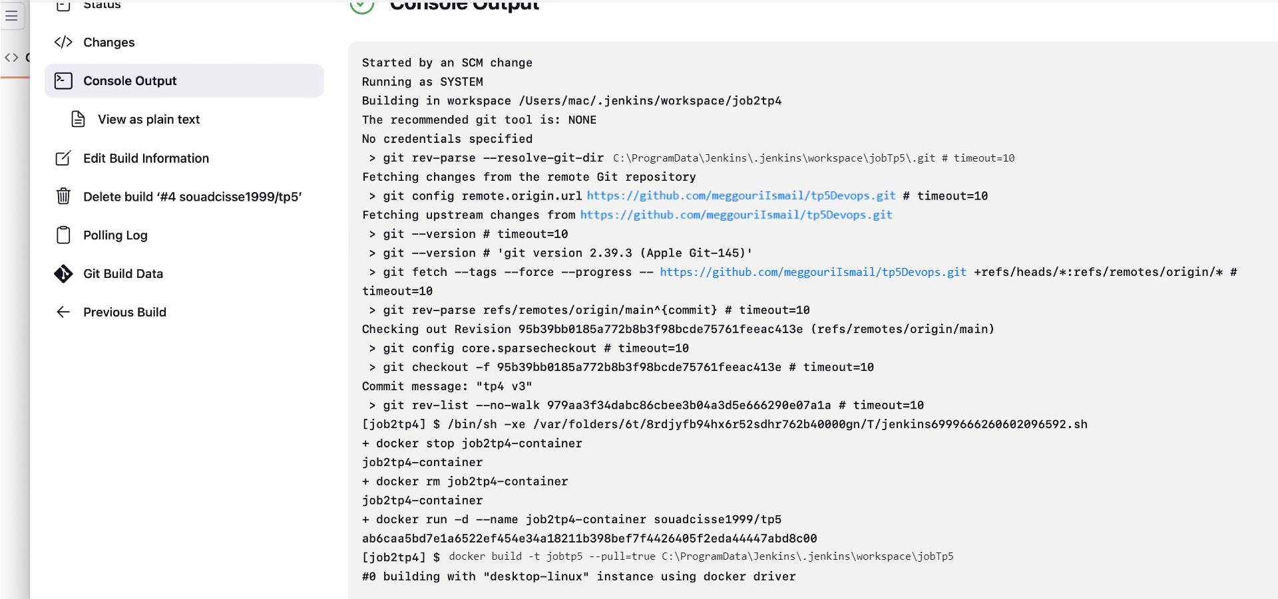
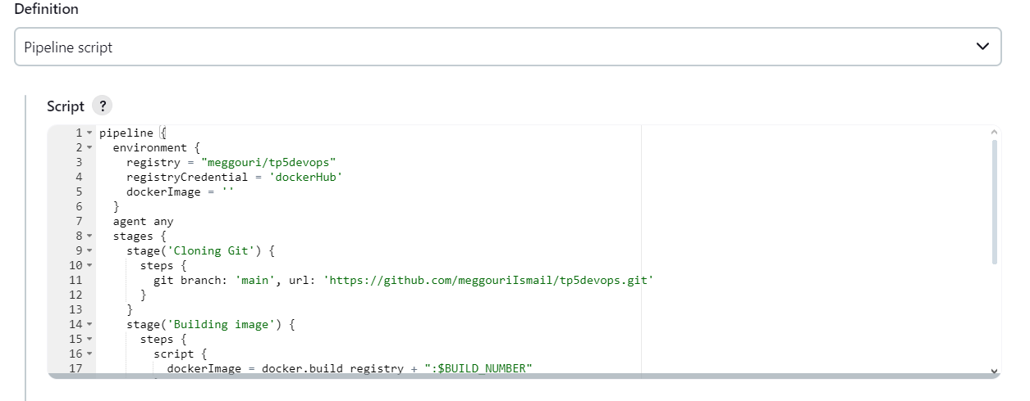
Changing index.html file:

